Northumberland County Blind Association
100 CLUB 2021

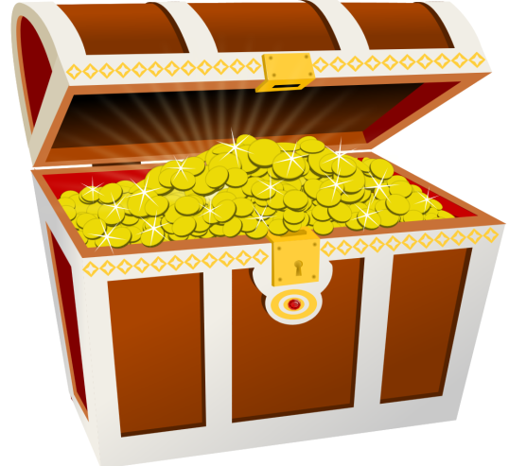
Due to its previous success, the
100 Club is continuing in 2021
and we would like to give you the
opportunity to become a member.

The 100 Club is a great way to donate
money to NCBA whilst at the same
time entering a draw with cash prizes for
3 lucky winners every month. Shares in the
Club are only £12 each for the entire year and
50% of Club funds will be distributed as prize money. Last year, a total of 126 shares were sold and the prize fund was set at £30, £20 and £12.50 each month.

If you wish to participate, please fill out the application form overleaf and return, along with a cheque / postal order for your 100 Club shares to our address detailed on the application form. Direct bank payments can also be made (see application form) but application forms must still be returned complete.

Finally, to all of you who have participated over recent years – your support has been invaluable in helping to raise funds and provide services for vision impaired people across Northumberland so a great big ‘THANK YOU!’ and best of luck for this year!!!

Northumberland County Blind Association

100 Club – Application for Membership

I wish to become a member of the Northumberland County Blind Association’s 100 Club in 2021 and understand that the annual subscription is £12 per share.

I wish to purchase…….share(s) and:

Enclose my cheque / postal order for £....... (payable to NCBA)

Have made a direct payment to NCBA bank account
77-20-37 03625260 Ref: 100 Club for £……

I understand that 50% of my subscription will be applied to the payment of prizes and that the balance will be used by the Association to further its work in Northumberland.

Name:…………………………………………………………………
Address:………………………………………………………………
…………………………………………………………………………
Postcode:……………………… Tel no:……………………..
Signed:………………………… Date:………………………

In order to keep costs to a minimum, we will not acknowledge your share purchase unless you call us (01670 514316).

Please return to: NCBA, Reiver House, Staithes Lane, Morpeth, Northumberland, NE61 1TD.

Thank you and good luck!

